**Megha Sharma**

**Pavani Sree Lakshmi Penumathsa**

**Reshma Reddy Thumma**

**Vinutha Nuchimaniyanda**

**Project Report E-Smart Application**

**Increment-2**

CS-5551 ASE

We have been able to implement the following features as part of the first and second increment of the project.

1. User login, registration & validation
2. Home Page
3. Energy Analyzer includes energy utilization analysis with weather conditions, cost analysis with consumption and detailed utilization over a period of one year.
4. Home Comfort
5. Find My Neighborhood
6. Survey based Budget my year, Recommendation and Tip of the day

**Web Client/Mobile UI Design**

To design the UI, we have used a combination JQuery, HTML5 and CSS. Most of the features have been supported by google and other web apis.

**Class Diagram**

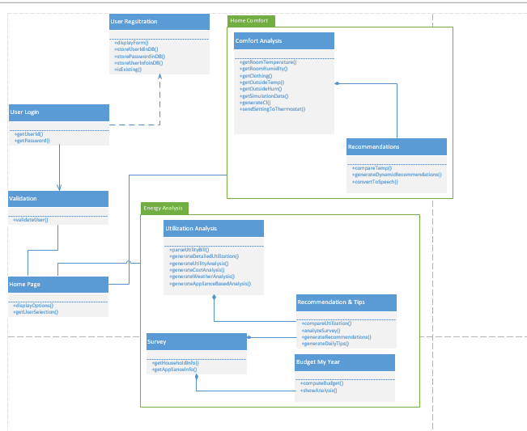

**Sequence Diagrams**

1. User Login and Service request

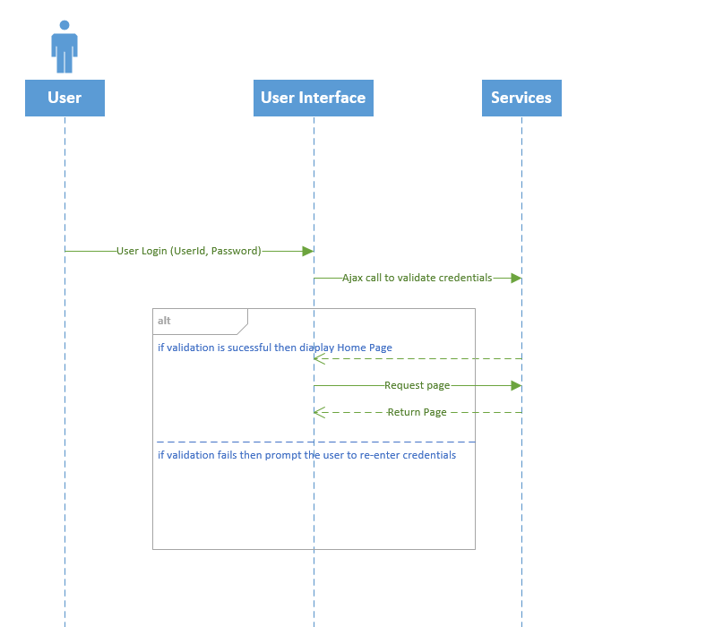

1. User Registration

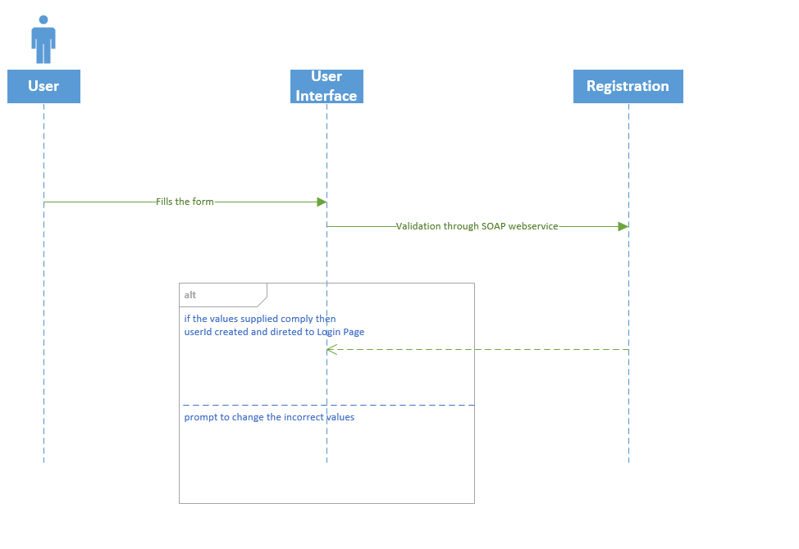

**System Architecture Design**

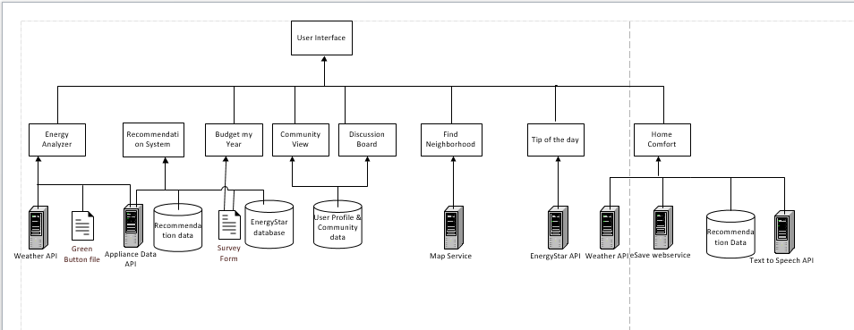

**Implementation Details**

The details of the features are below:

**1) User Login & Registration**

**Webservices/API:**

* We plan to use SOAP webservices to perform verification of user credentials and for storing user credentials in the database.

**Design & Implementation details:**

This page will allow the user to login to the E-Smart website. The validation is done based on the username and password entered by the user. If the validation is successful, it navigates to the website’s Homepage. If either username or password doesn’t match it shows the error message and will not allow the user to login to the website.

**Login page:** This page will allow the user to login to the E-Smart website. The validation is done based on the username and password entered by the user. If the validation is successful, it navigates to the website’s Homepage. If either username or password doesn’t match it shows the error message and will not allow the user to login to the website.

Login page using Opera:

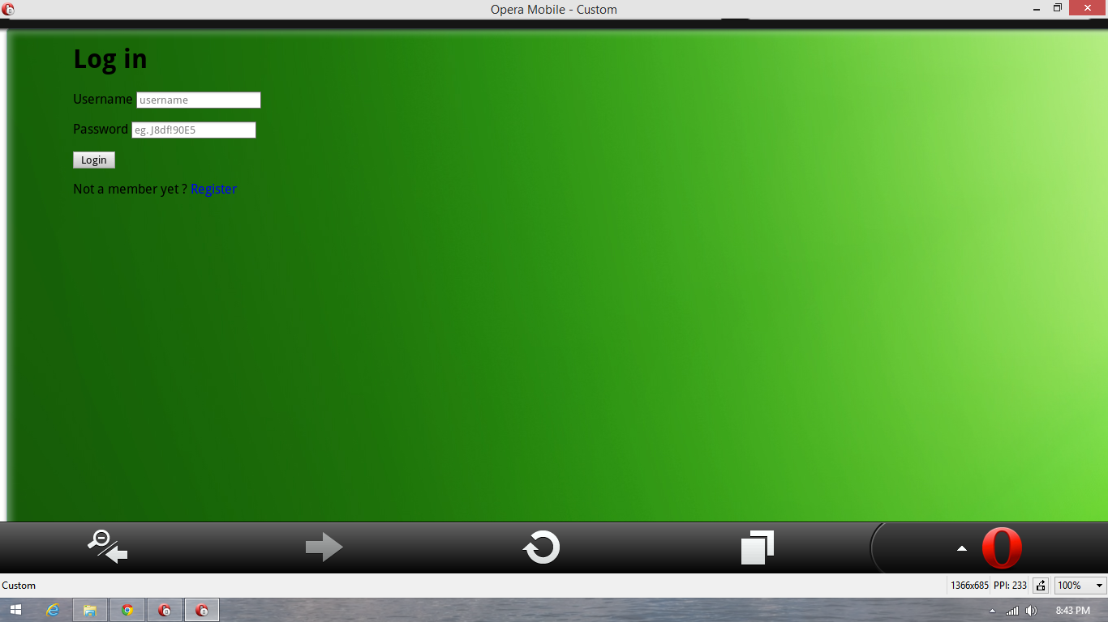

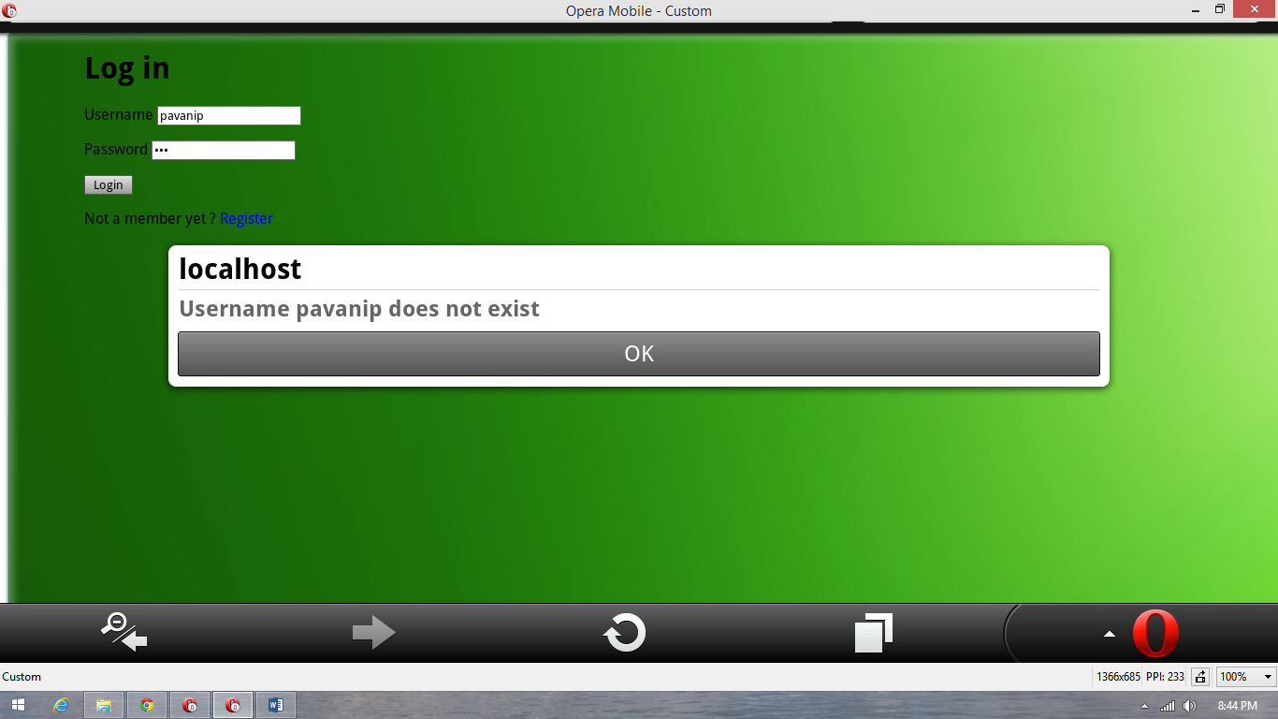

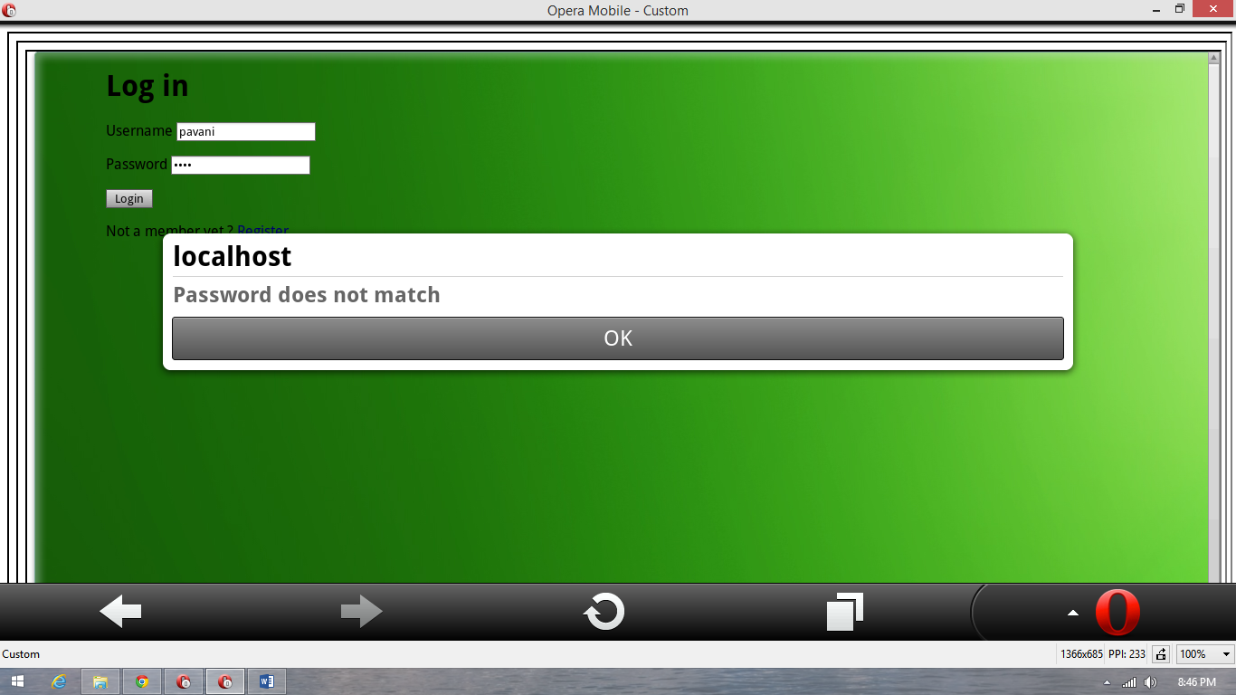

Changed the text color,

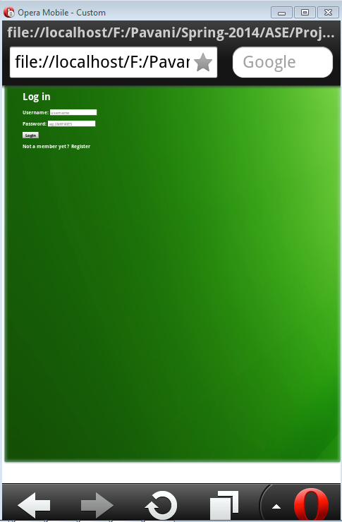

**Registration page:** This page will allow the user to register for accessing the E-Smart website. The **Register** button on the Login page navigates the users to this registration page. The user has to fill in his details, select username and password for this website. Once the registration is successful, it will navigate to the login page. The user can click on **Go and login** buttononthis page to go back to login page.

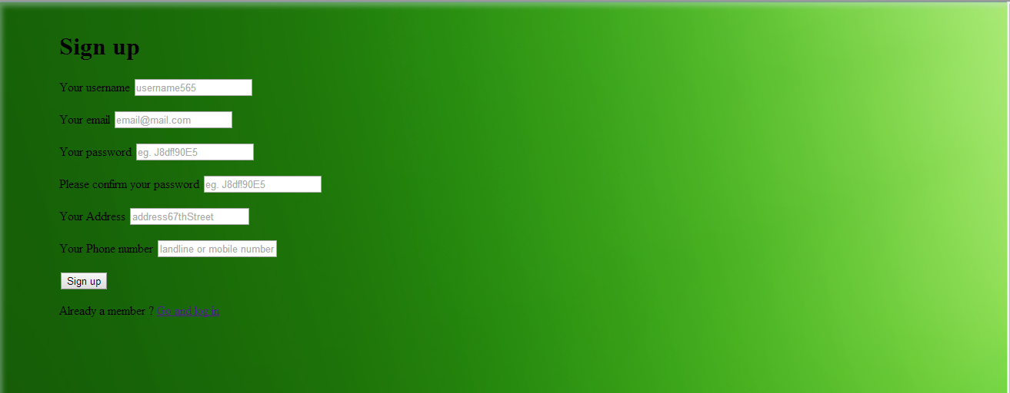

Registration page using Opera:

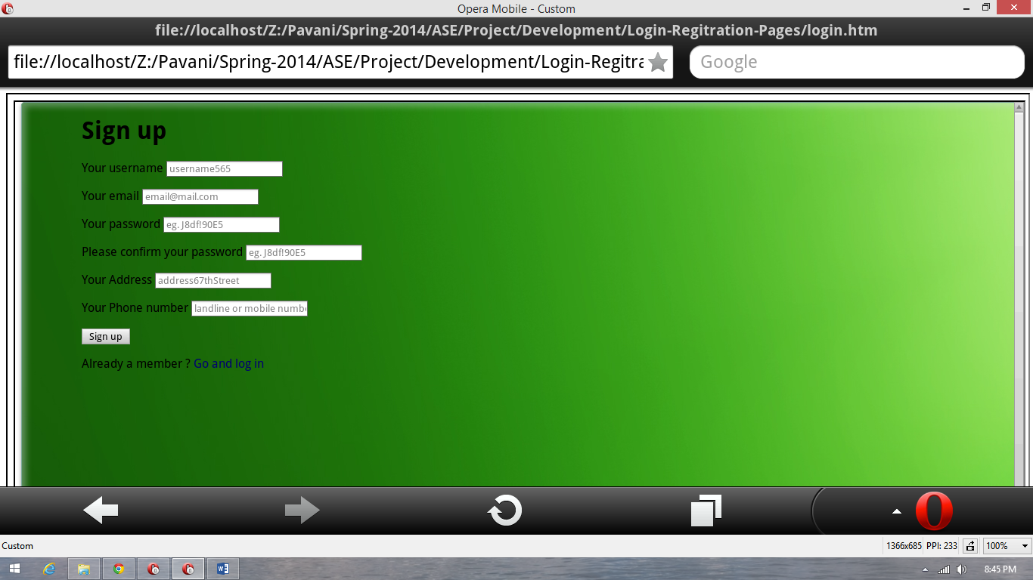

Added password validation in the 2nd increment,

It verifies whether both the entered password and confirm passwords match, if doesn’t match it will throw an error. It also checks if the entered password is greater than or equal to 8 characters long and it should have atleast one upper case letter, atleast one lower case letter, atleast one numeric value and atleast one special character.

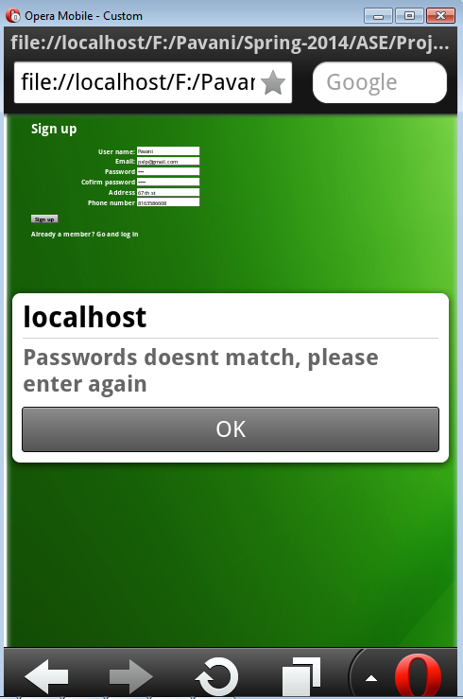

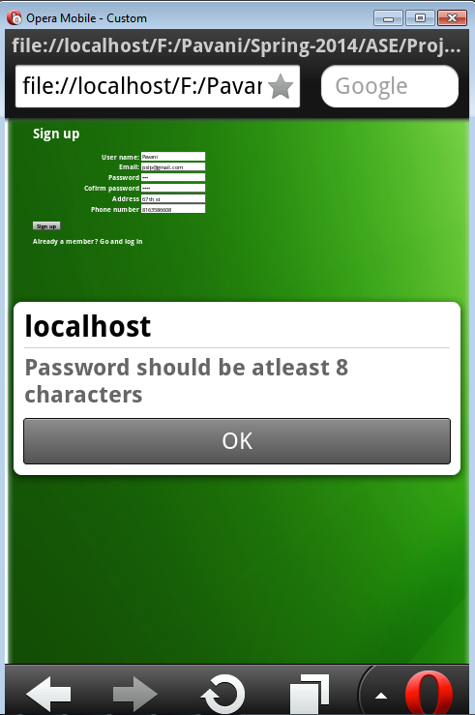

Now the registered user details are stored in Local SQL server database using the SOAP web service.

The SOAP web service inserts registered user data into database once the user enters his details and clicks on register button in the Signup page.

The SOAP web service also verifies whether the entered user name and password in the login page are available in the database and are correctly entered.

The SOAP Web service is deployed on the remote machine “KC-SCE-CS551.KC.UMKC.EDU” and accessed using the below URL.

<http://134.193.136.38/aspnet_client/Group5/WebSite5/WebService.asmx>

**2) Homepage**

On successful login the user is directed to the E-Smart homepage.

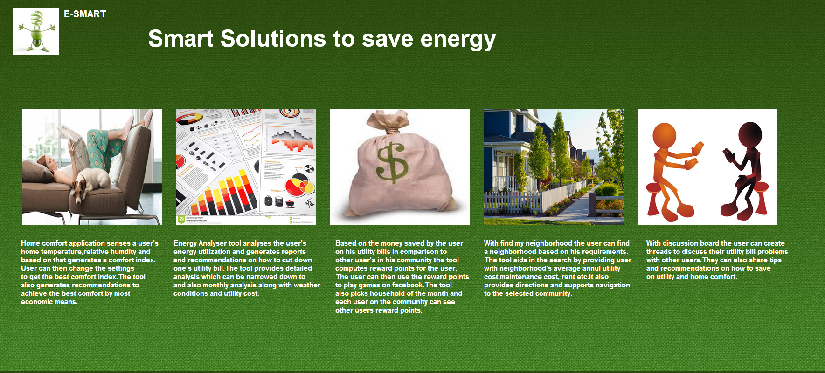

User Clicks on the images on the page which will then direct him to the next page he wants to visit. Home page links to Home Comfort, Energy Analyzer, Discussion Board, Find My Neighborhood, Survey pages.

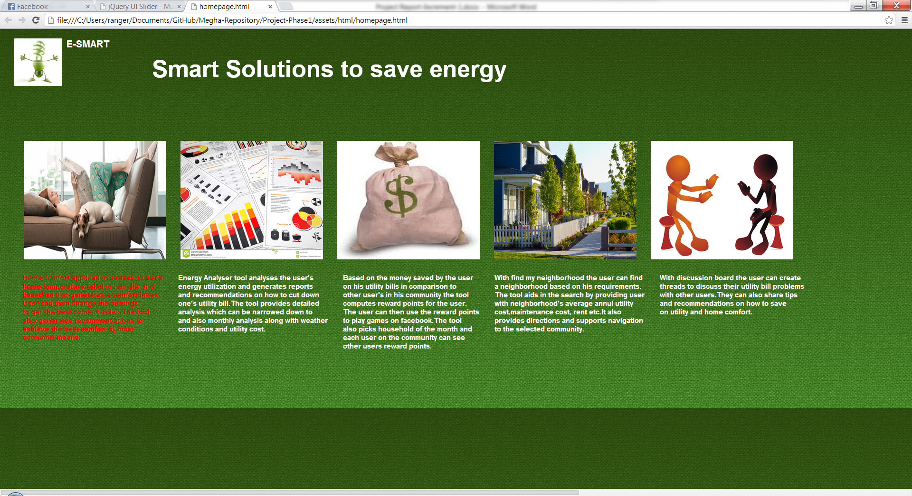

**2) Energy Analyzer**

**Webservices/API:**

* Google Visualization API Source
* Visualization ComboChart for Energy Analysis Monthly data.
* Visualization ScatterChart for Cost difference data
* Highcharts API
* WunderWeather API for weather data

**Design & Implementation details:**

This service takes in the user’s utility bill in green button format and parses it to get the energy utilization details. Energy consumption chart with difference in temperature and Cost analysis charts are generated. These are charts generated dynamically once the user uploads his monthly bill which is in green button format.

These charts give a complete picture of how much energy was used that allows the user to observe his energy consumption. Based on these charts, he can then use the other features in the website such discussion board or tips for the day to cut down his bill.

There are 5 charts.

1. Energy Utilization chart:

This chart provides information of energy utilization over period of 45 days. This chart shows the variation in energy utilization based on the temperature outside. The Scatter chart below is also generated for the parsed data which shows the cost difference with the amount of energy used. Below screen shots were taken on web client because of alignment problems with opera.

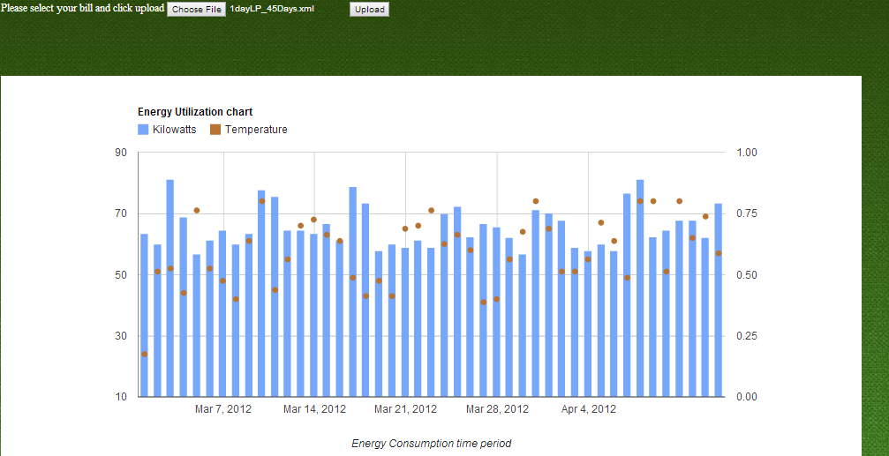

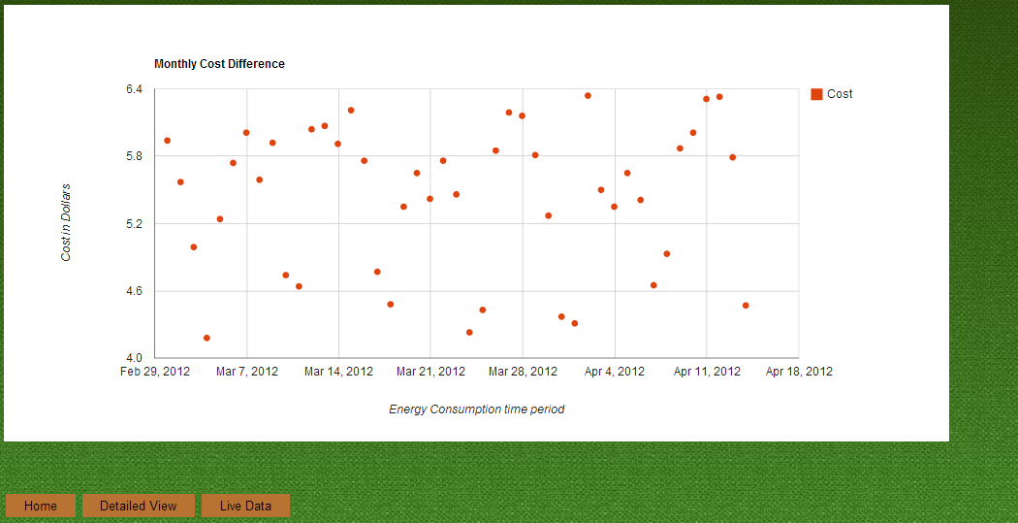

b. Detailed View:

The below is the graph gives the detailed view of the Energy and cost Analysis each day of the year. The graph gives the whole year view. The user has the option to zoom in the plot area and analyze the detailed view.

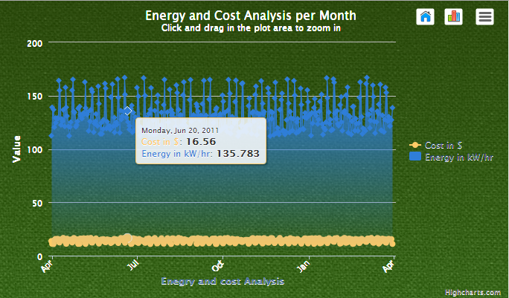

From the above graph user can select only the cost view or the energy view as shown below.

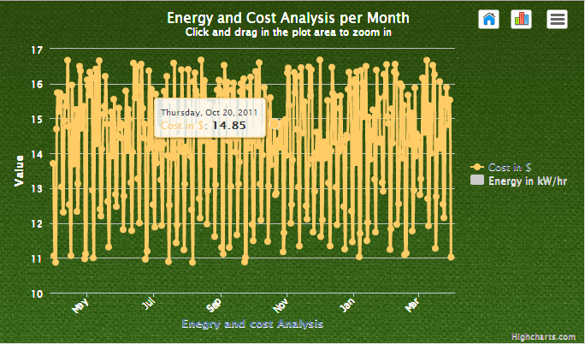

c. Live Data from the all appliances in a household:

Below is the dynamic graph generated from the live data. User can view data from past sec up to 20 minutes. This graph helps the user to understand which appliance is consuming more energy.

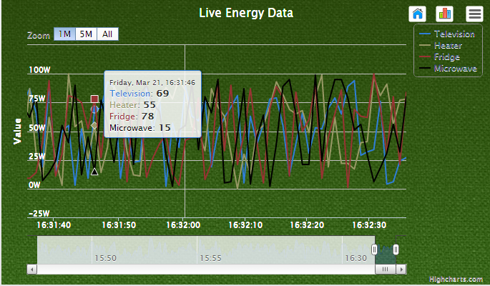

**3) Home Comfort**

**Webservices/API:**

* The geocode function supported by the browser has been used to detect user’s current location.
* The weather webservice by wunder “api.wunderground.com” has been used to populate the outside temperature and humidity.
* The jQuery UI sliders have been used for creating sliders on the home comfort page.
* The “google.visualization.Gauge” has been used to create the comfort index gauge.
* The text to speech service from tts.com has been used to convert to written recommendations to speech.

**Design & Implementation details:**

User Clicks on the Home Comfort Image.



The Page displays the user’s current home temperature and humidity and computes the Comfort Index (Comfort Index computation using formulae is yet to be implemented) of his home environment. This page also shows the outside temperature and humidity and displays a message providing an explanation of the comfort index.

If the comfort index is outside the comfort zone (in green) then it also shows a set of recommendations to make the comfort index fall into green zone. These recommendations are created by performing computation on his current home environment.

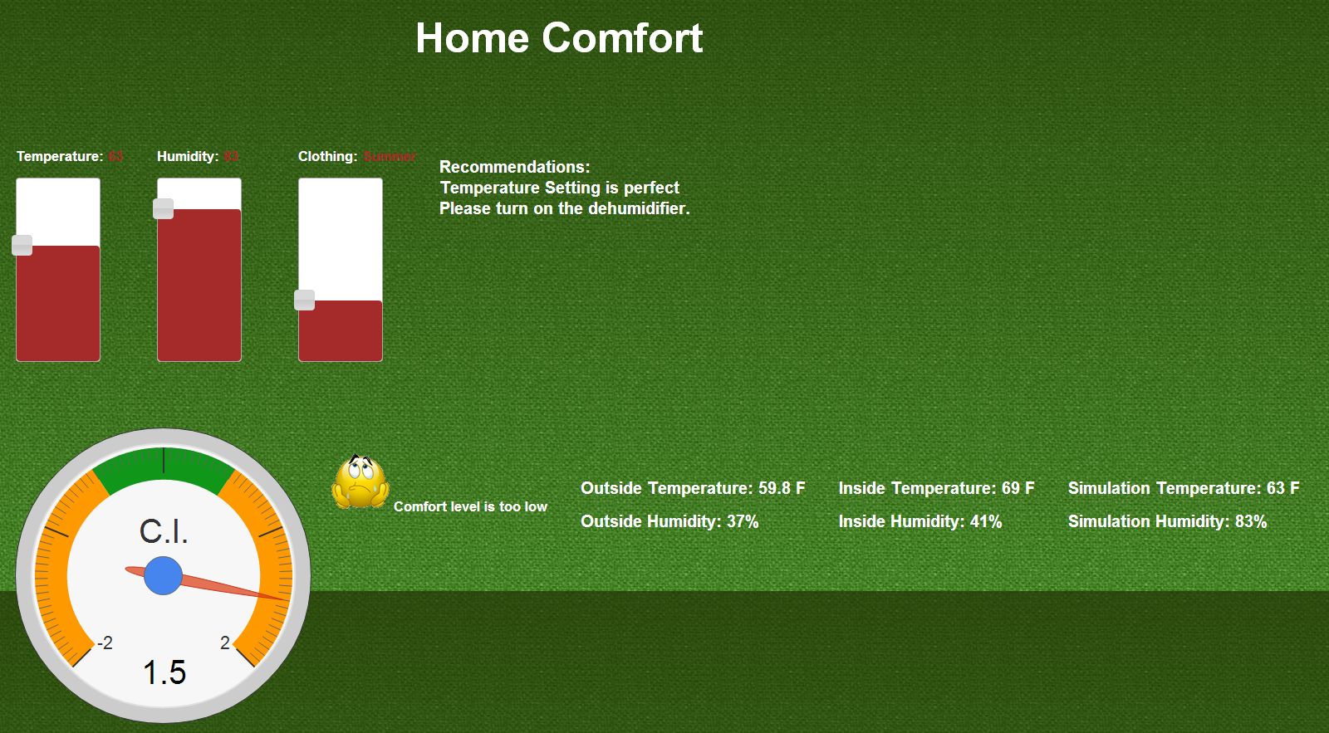

The user then tries to change the temperature, humidity and clothing based on the recommendations and a new comfort index is computed and displayed. The comfort index is now in the green zone so the user’s home environment is now comfortable.

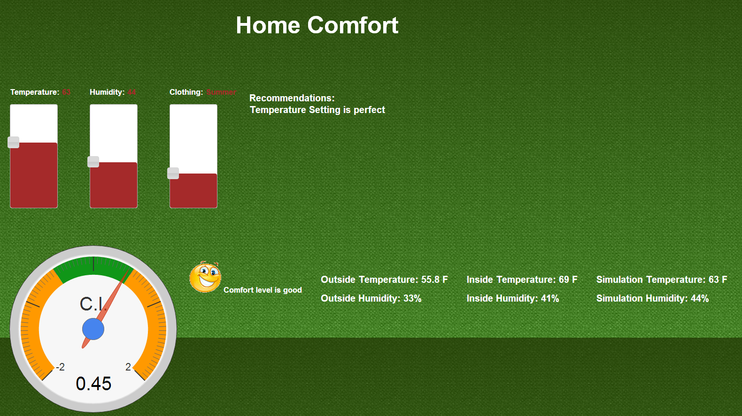

If the user sets the temperature too high or too low then the system prompts an alert message.

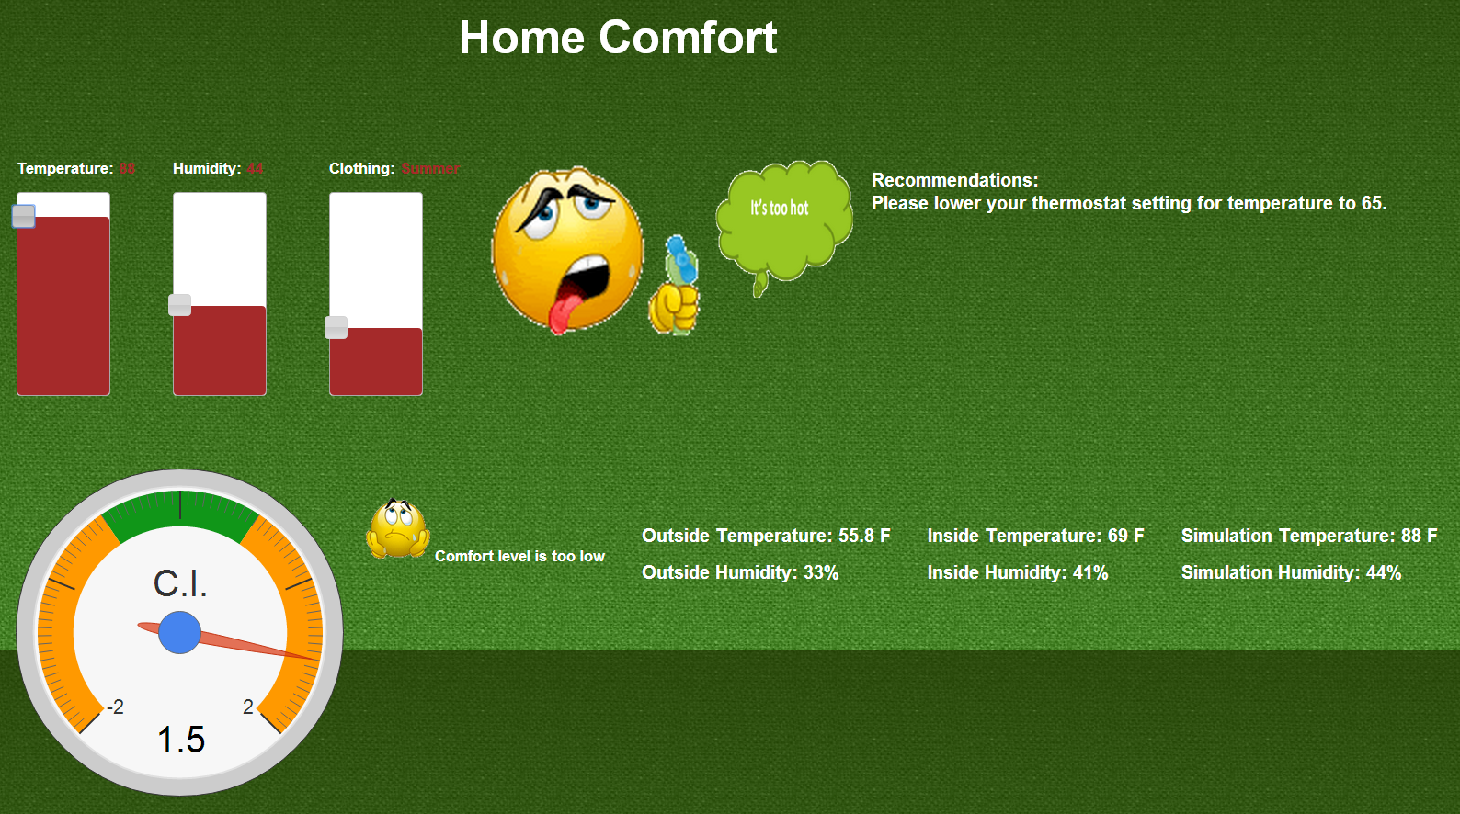

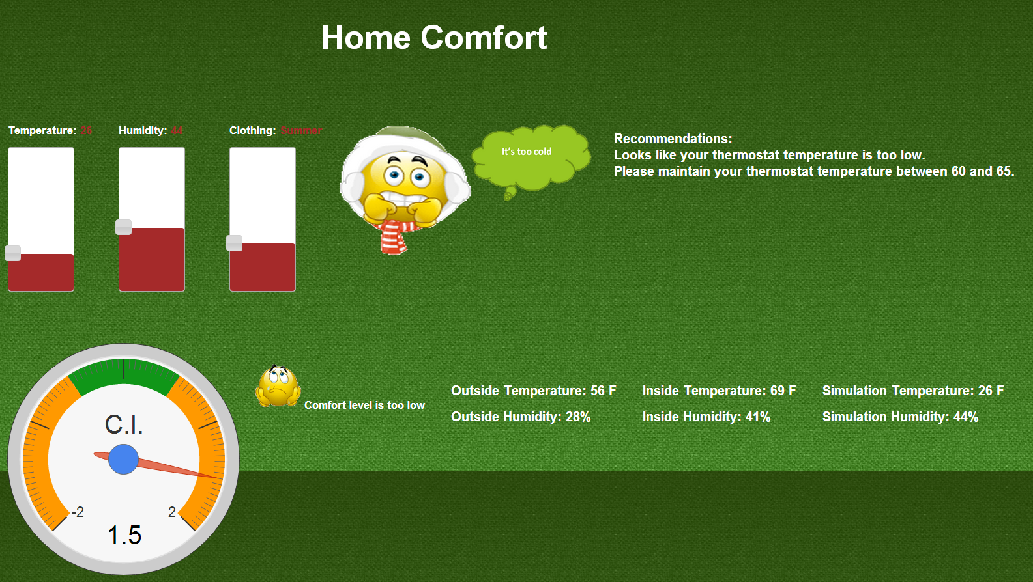

**5) Find My Neighborhood**

**Webservices/API:**

1. The geocode function supported by the browser has been used to detect user’s current location
2. Google map directions API
3. Google map direction display API

**Design & Implementation details:**

Find my neighborhood allows the user to search energy efficient neighborhoods around his current location. It gives details about the average energy consumption per household in a particular area along with maintenance details. We plan to extend the functionality with aerial navigation system and Text to speech API in the next increment. Below screen shots were taken on web client because of alignment problems with opera.

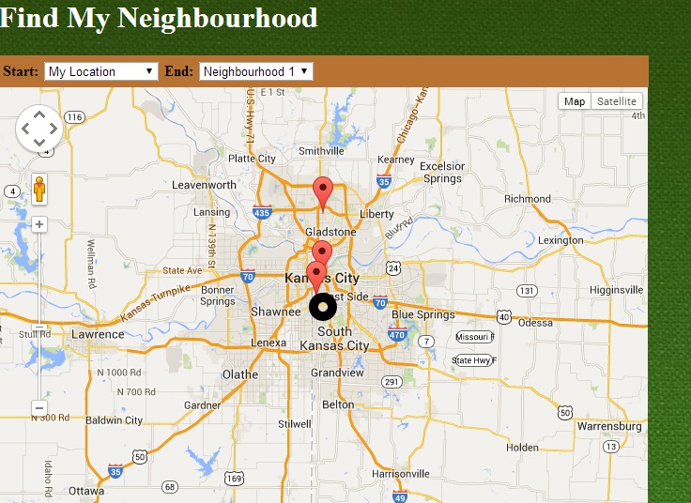

User can select the other neighborhood from the end drop box which will then show the directions to that place.

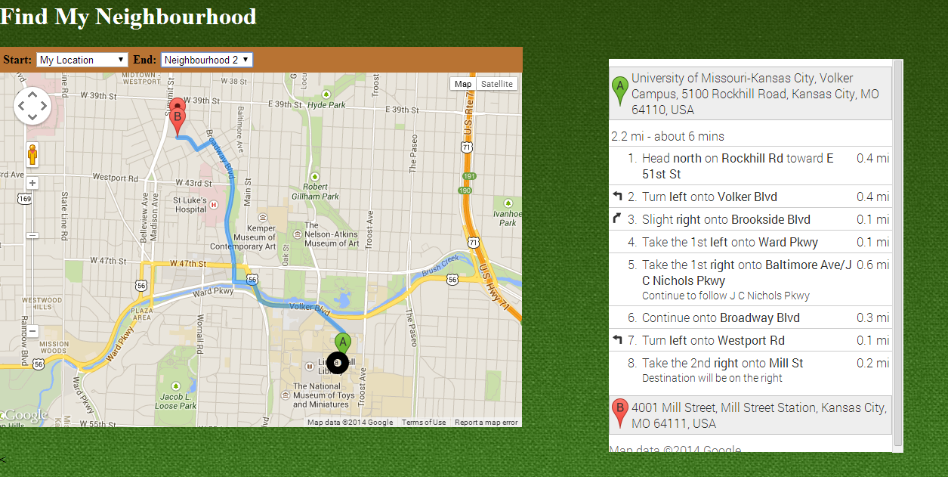

User can also find maintenance details at the bottom of the page

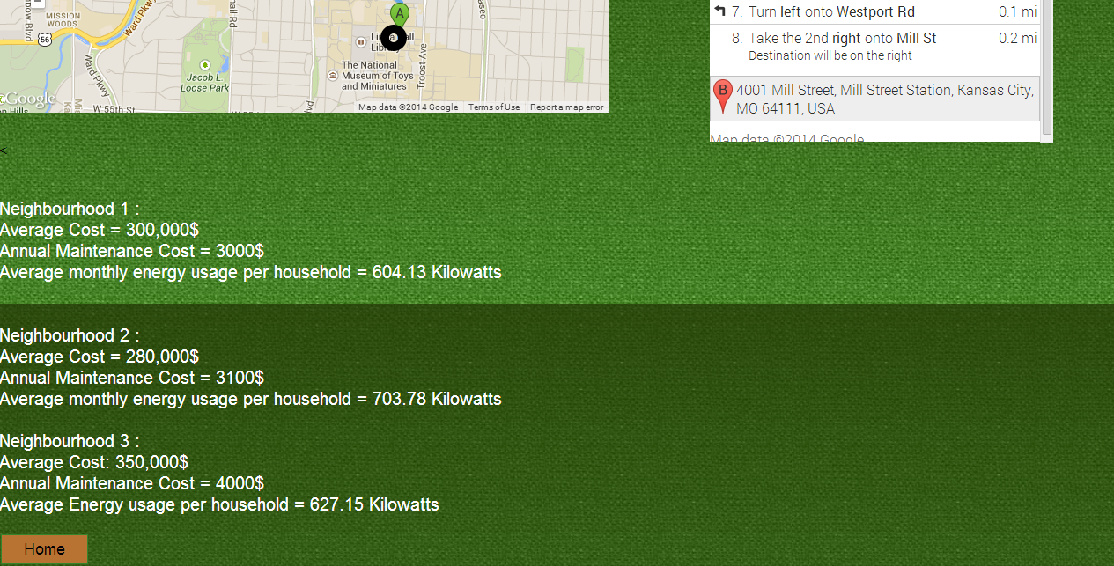

**6) Survey based Budget my year, Recommendation and Tip of the day**

**Webservices/API:**

* In future we will be using EnergyStar API to determine each appliance’s approximate energy consumption.
* Google visualization api has been used to generate charts.
* jQuery toggle used in recommendations page.

**Design & Implementation details:**

User clicks on the Budget My Year option which takes him to the survey page.

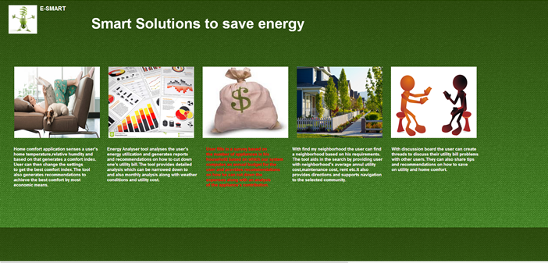

Below is the survey page where user can gets the options to fill household survey and Appliance Information.

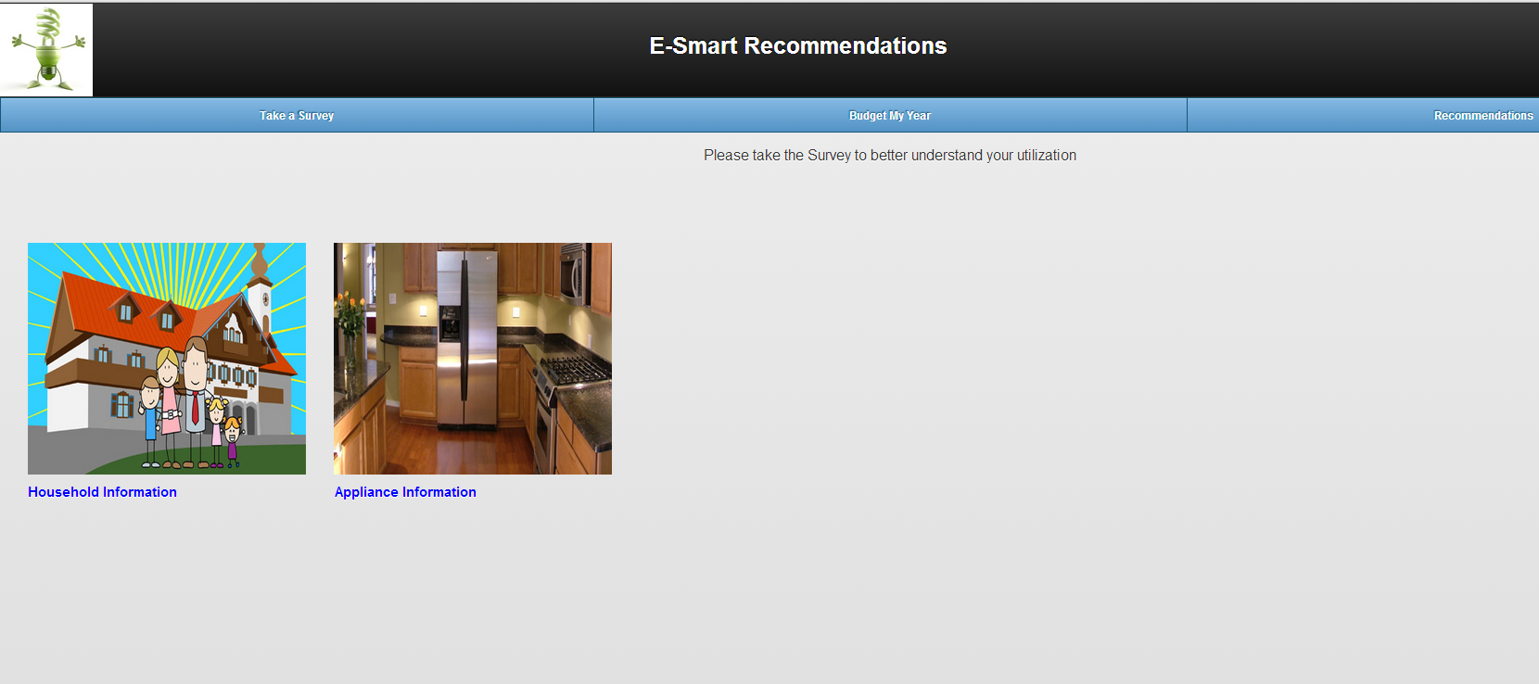

Below is the Household information part of the survey.

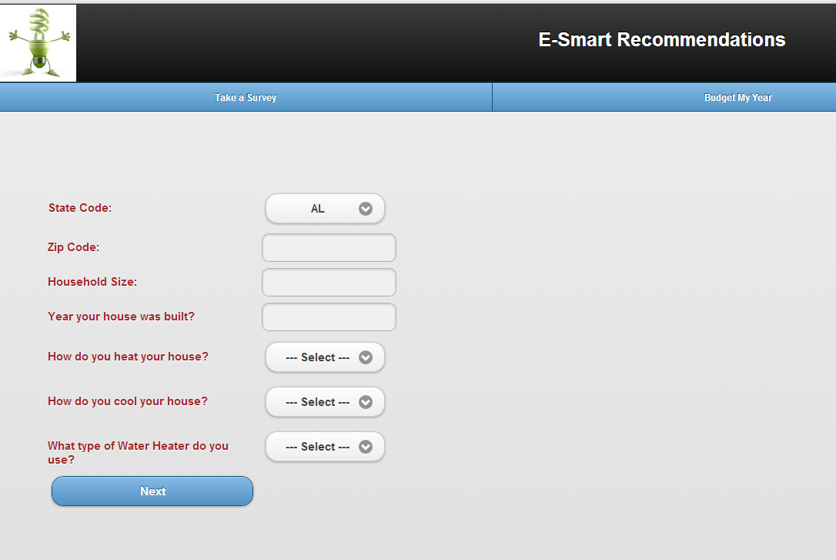

The next page takes him to the appliance based survey.

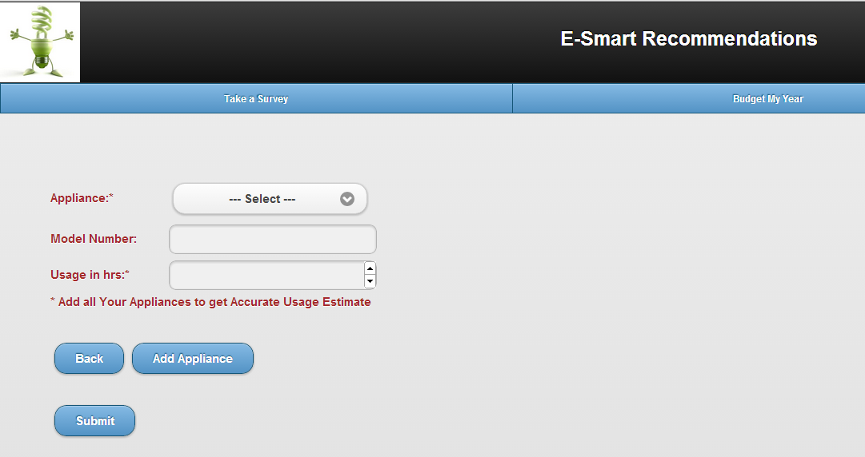

After entering all the appliances and clicking on submit, the system displays the below page.

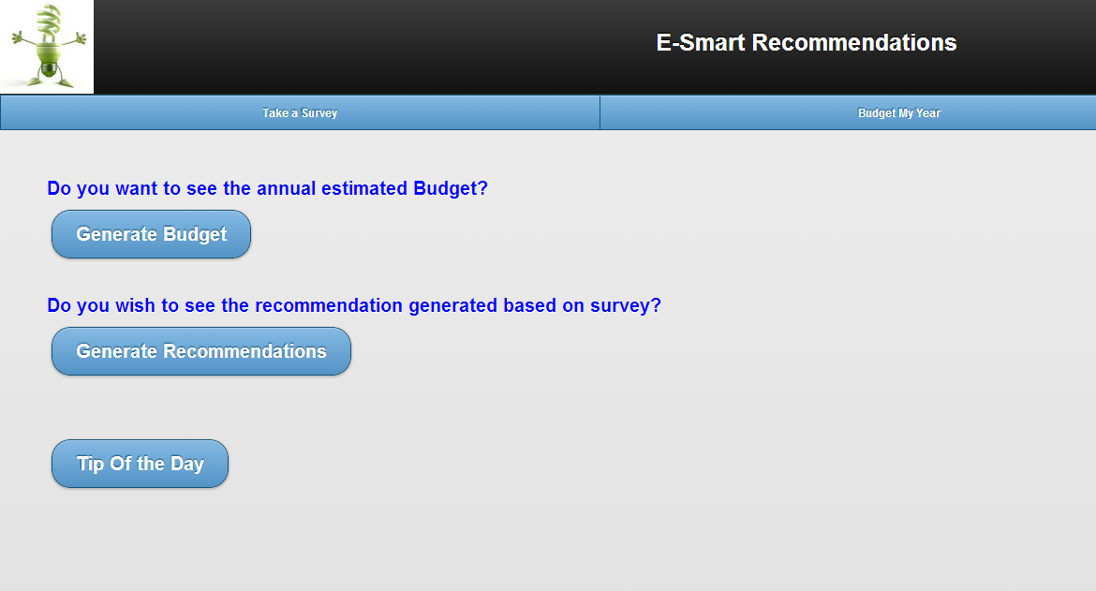

On clicking generate Budget, the system computes the user’s estimated budget generated based on the survey.

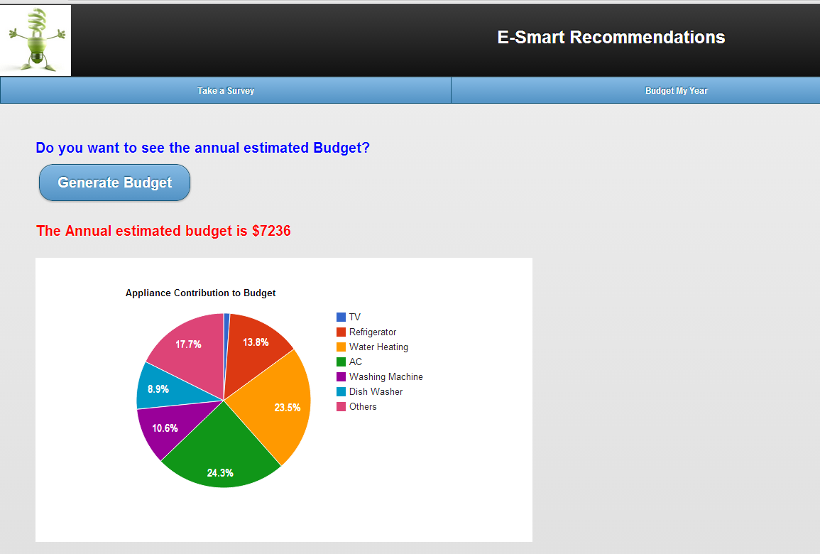

Clicking on generate recommendations takes him to another page which displays a set of appliance utilization recommendations generated based on the survey. A toggle feature in jQuery is used while designing this application. User can have a choice of selection which appliance recommendation he needs.

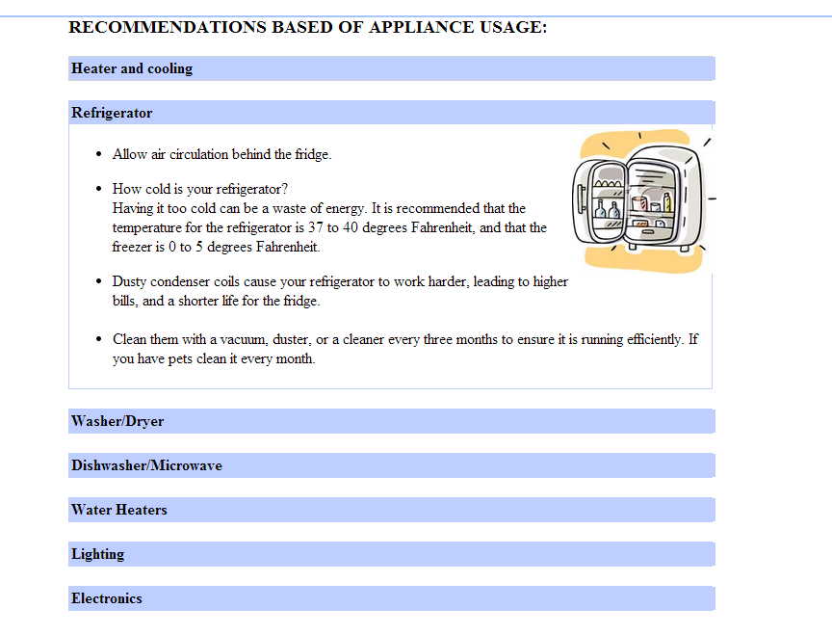

User can also choose to see the tip of the day.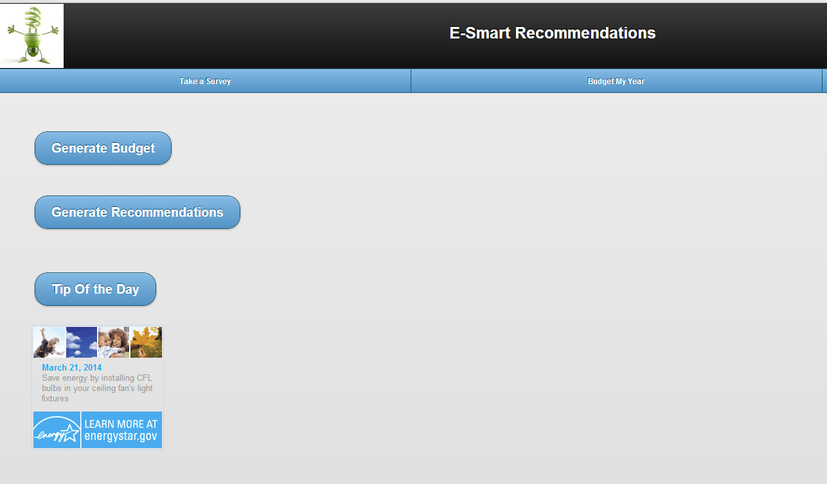

**Testing**

The unit testing has been performed manually as most of the webservices used were external.

**SOAP Web Service Nunit Testing**

The **SoapServiceInsertTest** method test the InsertTable method in the Soap Web service. The InsertTable method inserts the user details entered in the Signup page into the Local SQL server database using the Soap Web service.

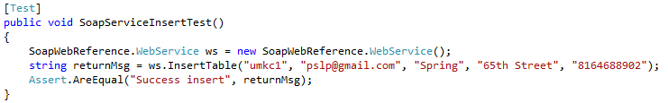

Test Results:

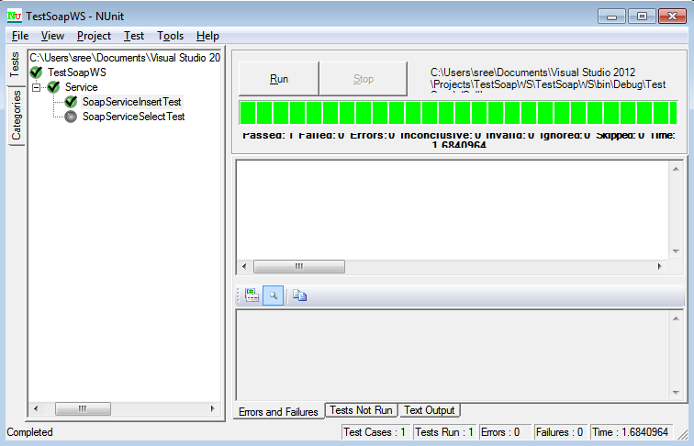

The **SoapServiceSelectTest** method test the queryTable method in the Soap Web service. The queryTable method fetches the user details entered in the Login page from the Local SQL server database using the Soap Web service for user login verification.

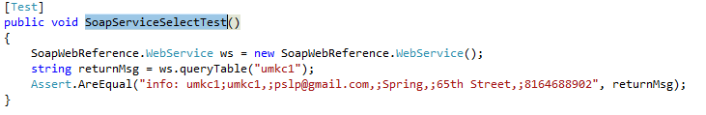

Test Results:

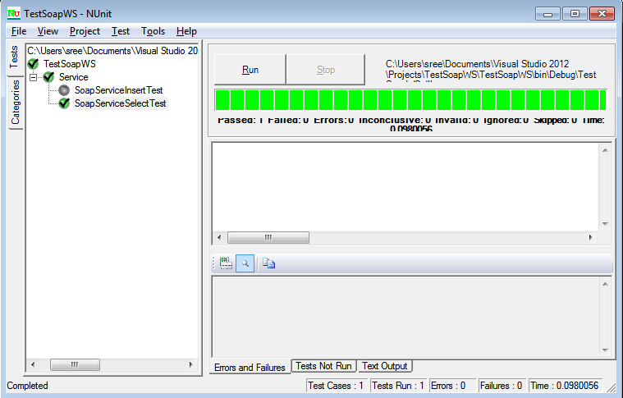

**Distribution of Work**

|  |  |  |
| --- | --- | --- |
| Responsibility | Time Taken | Person |
| Login & Registration | 20 | Pavani |
| Homepage | 4 | All |
| Energy Analyzer | 20 | Vinutha & Reshma |
| Home Comfort | 20 | Megha |
| Survey based Budget my year, Recommendation and Tip of the day | 20 | Megha and Reshma |
| Find My Neighborhood | 18 | Pavani & Vinutha |
| Reporting & Unit Testing | 5 | All |
| Scrum Do | 2 | Reshma |

**Git Hub Repository:**

[**https://github.com/mszzf/Megha-Repository/tree/master/Project-Phase1/assets**](https://github.com/mszzf/Megha-Repository/tree/master/Project-Phase1/assets)

**ScrumDo:**

[**https://www.scrumdo.com/projects/project/esmart/iteration/92363**](https://www.scrumdo.com/projects/project/esmart/iteration/92363)

**URL for site:**

**C:\inetpub\wwwroot\aspnet_client\Group5\group5\Iteration-2\assets\html\homepage.html**